Product Description

1. V7.020 KTM100 KTAG ECU Programming Tool Master software V2.25 with Unlimited Token
2. Available Protocols: BDM MOTOROLA MPC5xx
3. Easy to use, automatically recognize ECU model, high stability.
4. Multi-Language available:Italian Deutsch English French Portuguese Spanish

**V2.25 KTAG EU Online Version Firmware V7.020 K-TAG Master with Red PCB No Tokens Limitation  
  
What's new with Ktag Master fw V7.020 sw V2.25?**  
-Many encrypted new car models works I.E Toyota 76FXXX, PSA 17.4.4, Ford E83, VW 17.5.5 (1766), Mercedes-Benz 276ECU, Toyota 76F, etc.  
-100+ ECU types added   
-Software version: V2.25  
-Hardware version: V7.020

**Multi-Language available:**Italian Deutsch English French Portuguese Spanish  
**Support BDM Function Well, no checksum error, available Protocols BDM MOTOROLA MPC5xx  
Support both Car, Motorcyle and Truck ECU Programming  
Add New File type (FENDT/JCB/VALTRA TRACTOR BOSCH EDC17CV41 SISU ENGINE CAN**  
   
**Update:**By CD or Download link only. (I can give you a link to download newest version of ktag software)  
   
**Using tips:**  
1. Please Only Use Our Software  
**2. Operating System:** Better to Use Win XP  
**3. Tip (Very important):** During operation, disable the internet connection; otherwise the software may get damaged.

**1. What's main different between Our K-TAG KTAG 7.020 and others?  
-Mainly Different :  Our K-TAG 7.020 add a GPT cable to support GPT Functions** ( GPT is new password algo cryptography that is implemented in new Tricore microcontrollers. our KTAG v7.020 can easily read and decrypt the secret password and it automatically unlocks/unprotects the Tricore sectors so it can read and write both Flash and Eeprom )  
-*No reset button* ,no USB Dongle.***NO Tokens Limited!!!***  
-REAL VERSION OF KTAG 7020 EURO ALL ACTIVATED VERSION!!!

**2. What is the advantage of KTAG V7.020 over than other EUC Chip Tuning Tools in the market?**  
-Supports online full protocols ,fully activated,without tokens limited.  
-There are lot ECU that need to disassemble from the car and open and this is the case for all the ECU that need to be programmed with Jtag, BDM and Boot protocols, so KTAG is needed,as the new generation ktag master,ktag 7.020 is the best choice.  
-K-TAG 7.020 can work For Toyota Hilux kun26 and new added 100+ ECU types & supports new car models e.g. Toyota 76FXXX, PSA 17.4.4, Ford E83, VW 17.5.5 (1766), Mercedes-Benz 276 ECU, Toyota 76F, etc.  
-KTAG V7.020 add a cable with GPT Functions.  
-Online operation supported.  
-Best PCB With Murata filters.  
-Multi-Languages Supported .  
-With a great performance and tested by many tuners and was regarded as one of the best ECU Programmer for trucks ,heavy duty,boat.  
-No tokens limited, no years limited.  
-No USB Dongle,No reset button.

**3. KTAG v7.020 Red PCB ECU Tuning Tool Install/User Note**  
-The KTAG you received will with latest software 2.25 and hardware 7.020 ,so Never update it online.We will send you free update link in future.  
-We don't sell SD card and chips alone,sorry.  
-We offer free Transdata dimsport software for Ktag 6070,but no install help in this free gift.  
-Our KTAG 7.020 can be used online,no reset button need.No tokens limited  
  
**KTAG 7.020 Red PCB OBD2 Manager Tuning Kit PCB Display**

K-TAG red PCB EU Version PCB Component!  
  
1.  use of imported Japanese Murata NFE61PT472C1H9L filters  
2. 2.8x WFs = Infineon, BCR112 NPN Digital Transistor  
3. 3.7x 27E = ON Semiconductor NUP2105LT1G  
4. 4.8x 6DW = NXP BC817215 NPN Bipolar Transistor  
5. 5.3x A6c = MMUN2113LT1G / MMUN2113LT3G check your ktag PCB may already have 3 x A6c  
6. 6.2x K5B = BC807-25-7-F PNP Bipolar Transistor  
  
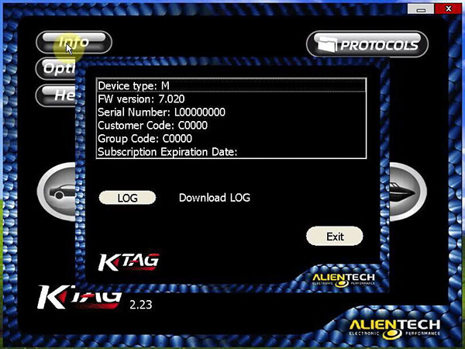  
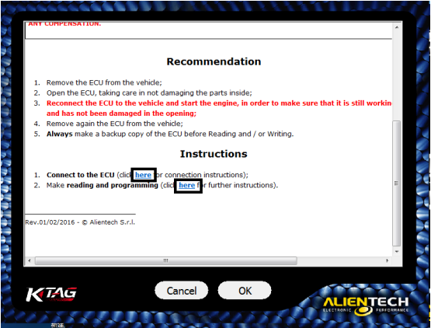  
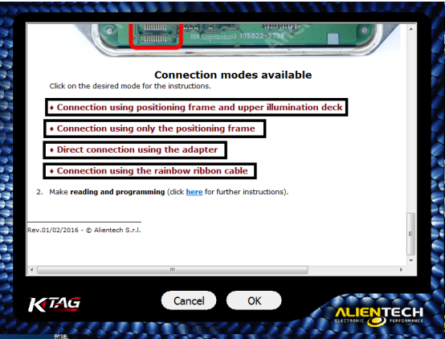  
  
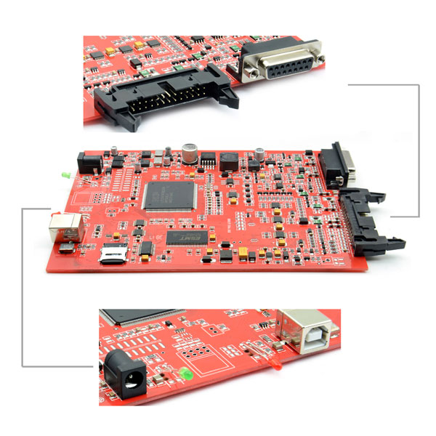  
**KTM100 KTAG Connection Picture Display:**  
  
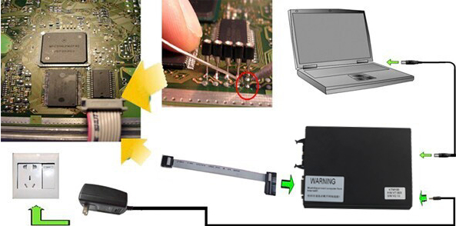  
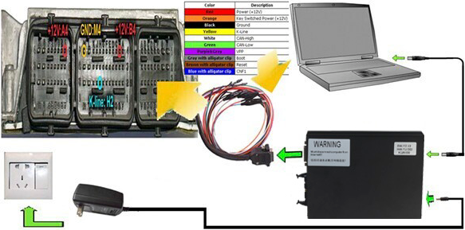  
**Cables From Left to Right:  
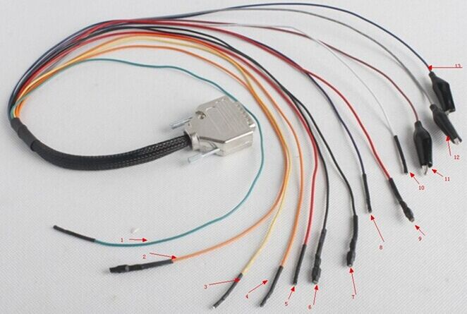**  
1.GREEN-CAN L  
2.ORANGE-VKEY  
3.YELLOW-K LINE  
4.ORANGE-VKEY  
5. RED-VECU  
6.BLACK-GND  
7.BLACK-GND  
8.PURPLE-VPP  
9.RED-VECU  
10.WHITE-CAN H

**Package includes:**  
   
1 x KTAG 7.020 Main Unit  
1 x 144300T 104  
1 x 144300T 103  
1 x 144300T 101  
1 x 144300T 106  
1 x 144300T 102  
1 x 144300T 105  
1 x 144300T 100  
3 x Chips Inside  
1 x Multi-Color Cable  
1 x USB Cable  
1 x Power Adapter  
1 x CD